## *Quiet* Worksheet

## *Download this worksheet to your computer and type in your answers.*

## Upon completion, submit to Instructor In-Box for grading.

## Exercise 1: For 5 points, what kind of “quiet” are you?

Look at the characteristics of introversion, shyness and high sensitivity.

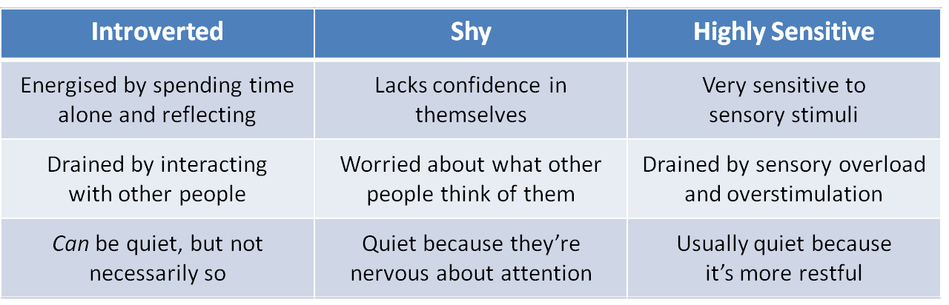

Rate yourself on a scale of 1-5 (1 being “not at all” and 5 being “completely!) for how each trait applies to you.

|  |  |  |  |  |  |
| --- | --- | --- | --- | --- | --- |
| **Trait** | **1** | **2** | **3** | **4** | **5** |
| Introverted |  |  |  |  |  |
| Shy |  |  |  |  |  |
| Highly sensitive |  |  |  |  |  |

If you rated yourself as a 3 or higher on any of the scales, explain how your introversion, shyness, and high sensitivity affect your daily life.

Personally, I like to be in my own space and I so much love it because it helps me think better. Although, when I am in the mist of strangers, I feel a little bit unease and sometimes lack confidence in sharing my thoughts but once I feel comfortable with the people around me, I become energetic and lively.

## Exercise 2: For 5 points, identify your strengths as an introvert*

Again, rate yourself on a scale of 1-5 (*1 being “not at all” and 5 being “completely!*) for each strength.

|  |  |  |  |  |  |
| --- | --- | --- | --- | --- | --- |
| **Strength** | **1** | **2** | **3** | **4** | **5** |
| Researching |  |  |  |  |  |
| Concentrating |  |  |  |  |  |
| Thinking things through before you act |  |  |  |  |  |
| Intuition |  |  |  |  |  |
| Focussing on detail |  |  |  |  |  |
| Working independently |  |  |  |  |  |
| Building deep, lasting relationships |  |  |  |  |  |
| Listening attentively |  |  |  |  |  |
| Problem solving |  |  |  |  |  |
| Writing |  |  |  |  |  |
| Other strength 1: Critical Thinking |  |  |  |  |  |
| Other strength 2: (type in here) |  |  |  |  |  |
| Other strength 3: (type in here) |  |  |  |  |  |

Where are you strongest?

Critical Thinking and Intuition

How you can you bring these strengths into your school work and social activities?

I can leverage my strengths and helping to solve people problem around me but in and outside of the class and school works.

Name two areas where you are weakest. How could you improve in these areas?

Meeting strangers and expressing myself.

I could improve in my weakness by using my strength to solve people’s problem and connect with them. But my problem is that I can’t just walk up to a random person and start the talk.

* *Introvert strengths taken from Self-Promotion for Introverts by Nancy Ancowitz, pp41-42*

## Exercise 3: For 10 points, understand what affects your energy levels

|  |  |
| --- | --- |
| **Write down three recent interactions that left you drained** | **Write down three recent interactions that left you energized** |
| 1. Transportation (Moving from one place to another) 2. While I was waiting for my internet connection to be fixed. 3. When the payment gateway couldn’t process my payment while shopping online. | 1. My sister’s birthday 2. When I got 4 colleague’s package delivery sorted and all delivered. 3. When I was able to figure out the cause of an error on my computer. |
| **What factors did the three interactions above have in common?** | **What factors did the three interactions above have in common?** |
| All of the interactions put me in the state of stress and make me unnecessarily bothered. | All of the interactions come with a level of satisfaction and happiness. |
| **How could you avoid or manage these factors in your work or student activities?** | **How could you include these factors in your work or student activities?** |
| The way I could manage or avoid these situations is to avoid relying on anyone for some solution to a problem at any point | A level of satisfaction could be included in my activities, such as milestones. This way, I am satisfied for each activity or group of activities that I am able to complete. |

## Exercise 4: For 5 points, how do you recharge your energy levels?

Imagine yourself as a battery that’s drained by social interaction. Think about the kinds of activities that typically “recharge” you.

Identify three solo activities that allow you to charge up your energy levels before a draining situation, or recharge them afterwards:

1. Listening to Songs, Music and Rhymes
2. Playing Video games
3. Dancing / Exercise

How can you schedule time for these activities before and/or after a draining social interaction or event?

I can carry out any of the activities that recharge my energy in between events and interactions in other to remain charged during the event.